A PROJECT REPORT

ON

**LIBRARY**

**MANAGEMENT** **SYSTEM**

FOR AISSCE 2020 EXAMINATION

[AS A PART OF THE INFORMATICS PRACTICES COURSE (065)]

SUBMITTED BY: -

NAME: _________________

ROLLNO: _________________

UNDER THE GUIDANCE OF: MR.AMIT SETHI (COMP.SC)

CERTIFICATE

This is to certify that the Project / Dissertation entitled LIBRARY MANAGEMENT System is a bonafide work done by ____________________ of class XII Session 2019-20 in partial fulfilment of CBSE’s AISSCE Examination 2020 and has been carried out under my direct supervision and guidance. This report or a similar report on the topic has not been submitted for any other examination and does not form a part of any other course undergone by the candidate.

………………….. ……………………..

.Sc. Signature of Student Signature of Teacher/Guide

Name: Name: MR.AMIT SETHI

Roll No.:

ACKNOWLEDGEMENT

I, undertook this Project work, as the part of my XII-Informatics Practices course(065). I had tried to apply my best of knowledge and experience, gained during the study and class work experience. However, developing software system is generally a quite complex and time-consuming process. It requires a systematic study, insight vision and professional approach during the design and development. Moreover, the developer always feels the need, the help and good wishes of the people near you, who have considerable experience and idea.

I would like to extend my sincere thanks and gratitude to my teacher

Ms. Honey Kaur , for giving valuable time and moral support to develop this software.

I also feel indebted to my friends for the valuable suggestions during the project work.

_______________

Class XII

C O N T E N T S

1. Introduction ------------------------------------------------------------------- 5

2. Objective & Scope of the Project ------------------------------------- 6

3. System Implementation -------------------------------------------------- 8

3.1 The Hardware used:----------------------------------------------------- 8

3.2 The Software’s used: ---------------------------------------------------- 8

4. Event Coding: -----------------------------------------------------------(9-23)

5. Output------------------------------------------------------------------------(24-34)

6. User Manual ----------------------------------------------------------------( 35-36)

6.1 How to install: ---------------------------------------------------------- (35-36)

6.2 Working with Software: ----------------------------------------------- (35-36)

7.References -----------------------------------------------------------------37

1.Introduction

This software project is developed to automate the functionalities of LIBRARY MANAGEMENT SYSTEM.

The purpose of the software project is to develop the Management Information System (MIS) to automate the record keeping of products, purcahses , stock and sales transactions with a view to enhance the decision making of the functionaries.

A MIS mainly consists of a computerized database, a collection of inter-related tables for a particular subject or purpose like reference of product_id in all tables , capable to produce different reports relevant to the user. An application program is tied with the database for easy access and interface to the database. Using Application program(Python) or front-end, we can store, retrieve and manage all information in proper way.

This software, being simple in design and working, does not require much of training to users, and can be used as a powerful tool for automating a FASHION STORE MANAGEMENT SYSTEM.

During coding and design of the software Project, Python IDLE, as a powerful front-end tool is used for getting Graphical User Interface (GUI) based integrated

platform and coding simplicity. As a back-end a powerful, open source RDBMS, MySQL is used as per requirement of the CBSE curriculum of Informatics Practices Course(065).

2. Objective & Scope of the Project

The objective of the software project is to develop a computerized MIS to automate the functions of a LIBRARY MANAGEMENT SYSTEM. This software project is also aimed to enhance the current record keeping system, which will help managers to retrieve the up-to-date information at right time in right shape.

The proposed software system is expected to do the following functionality-

ü To provide a user friendly, Graphical User Interface (GUI) based integrated and centralized environment for MIS activities.

ü The proposed system should maintain all the records and transactions, and should generate the required reports and information when required.

ü To provide graphical and user-friendly interface to interact with a centralized database based on client-server architecture.

ü To identify the critical operation procedure and possibilities of simplification using modern IT tools and practices.

In its current scope, the software enables user to retrieve and update the information from centralized database designed with MySQL . This software does not require much training time of the users due to limited functionality and simplicity.

During the development of LIBRARY MANAGEMENT SYSTEM project, Python IDLE, a powerful, open source event-driven form-based development environment is used for modular design and future expandability of the system.

Despite of the best effort of the developer, the following limitations and functional boundaries are visible, which limits the scope of this application software.

1. This software can store records and produce reports in pre-designed format in soft copy. There is no facility yet to produce customized reports. Only specified reports are covered.

2. There is no provision to calculate profit or loss etc. for the store; however it can be developed easily with the help of adding modules.

3. It facilitates manager to record and update only transaction record.

So far as future scope of the project is concerned, firstly it is open to any modular expansion i.e. other modules or functions can be designed and embedded to handle the user need in future. Any part of the software and reports can be modified independently without much effort.

3. System Implementation

3.1 The Hardware used:

While developing the system, the used hardware are:

PC with Intel Core i5-2400S processor having 4.00 GB RAM,64 BIT

Operating System , SVGA and other required devices.

3.2 The Softwares used:

Ø Microsoft Windows® 10 Pro as Operating System.

Ø Python 3.8.2 as Front-end Development environment.

Ø MySQL as Back-end Sever with Database for Testing.

Ø Mysql.connector to connect Python module with database.

Ø MS-Word 2010 for documentation.

CODING

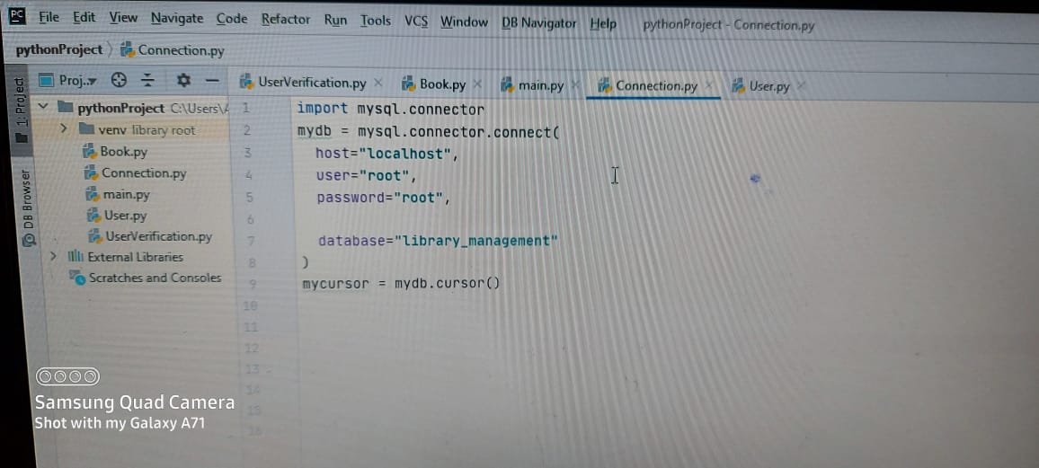

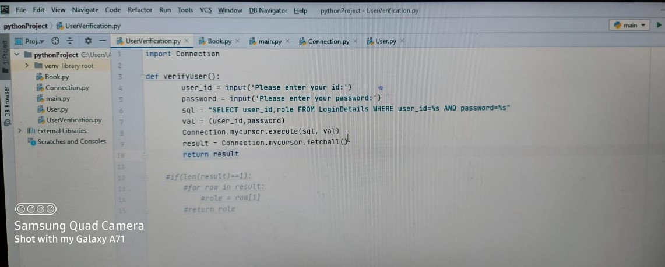

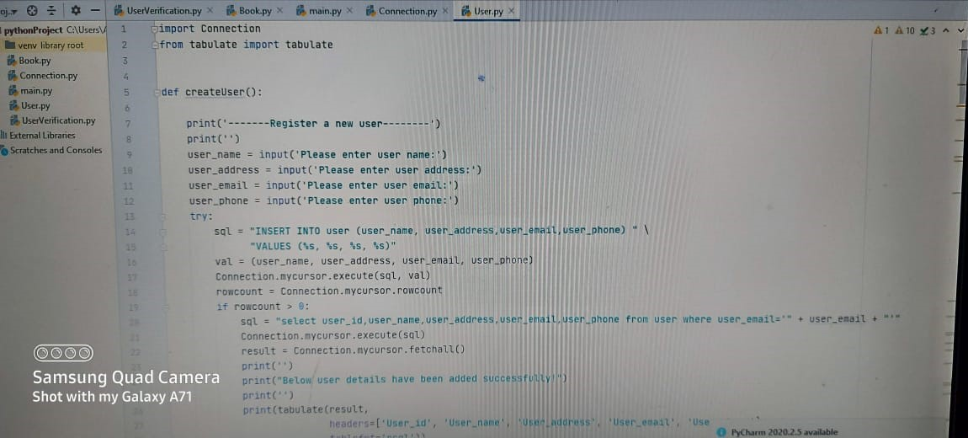

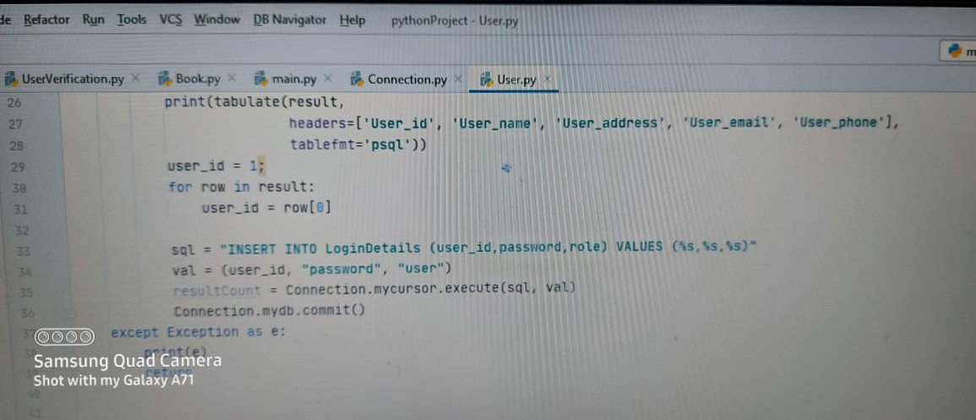

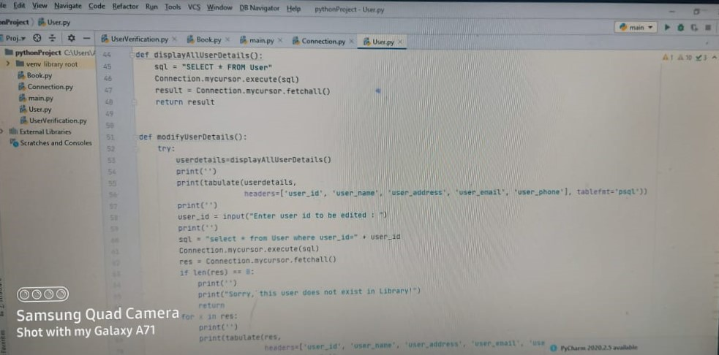

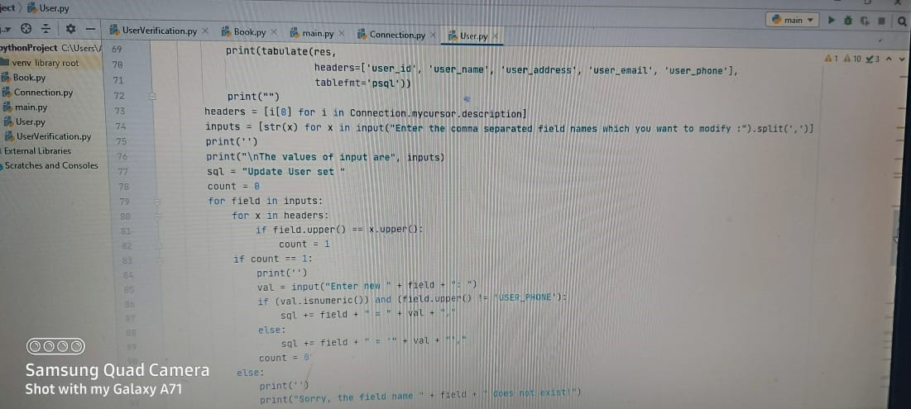

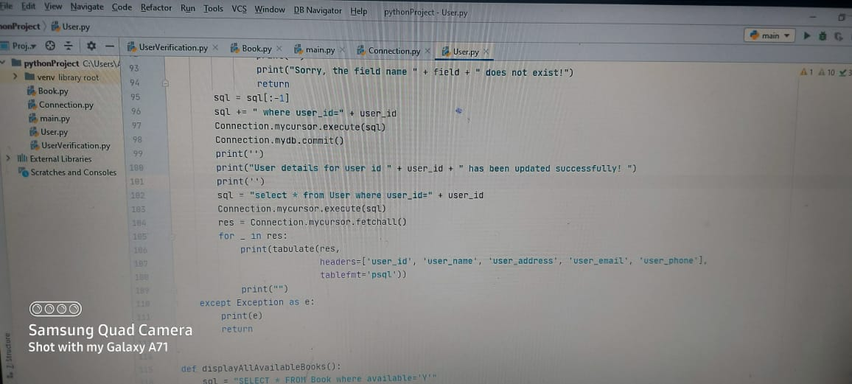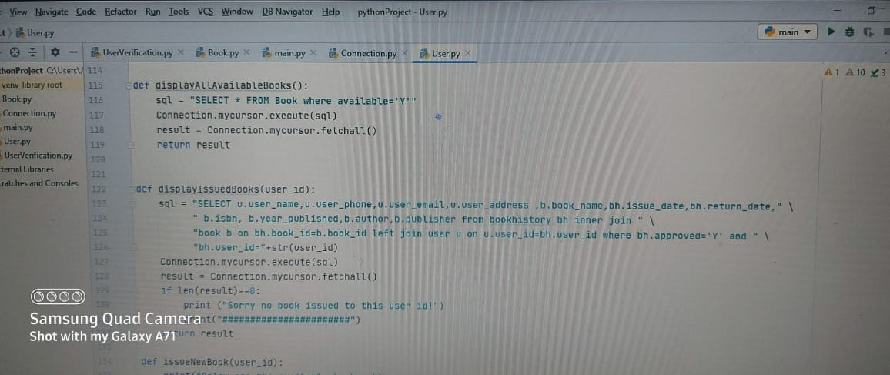

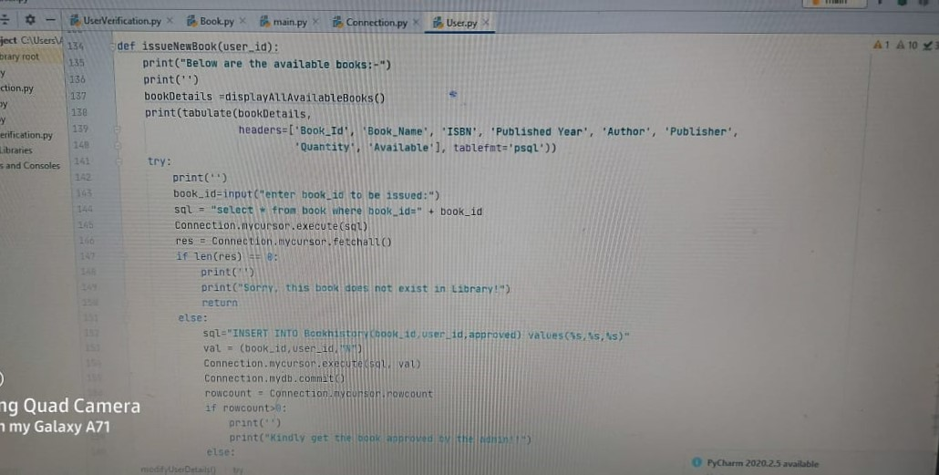

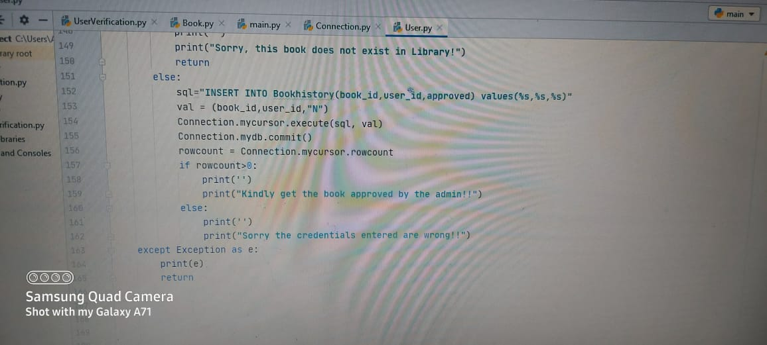

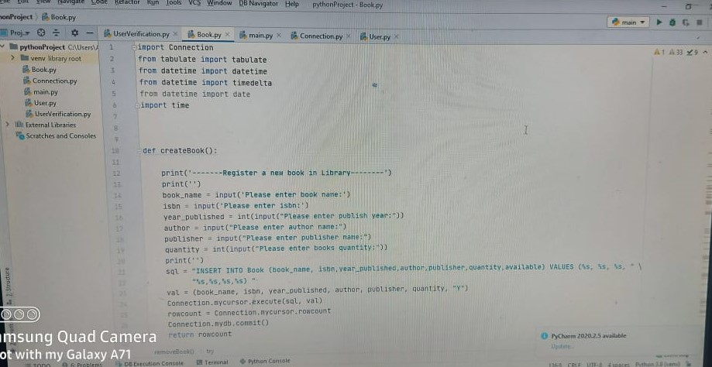

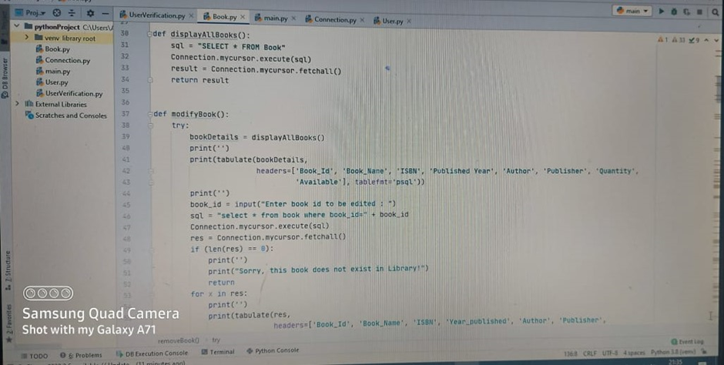

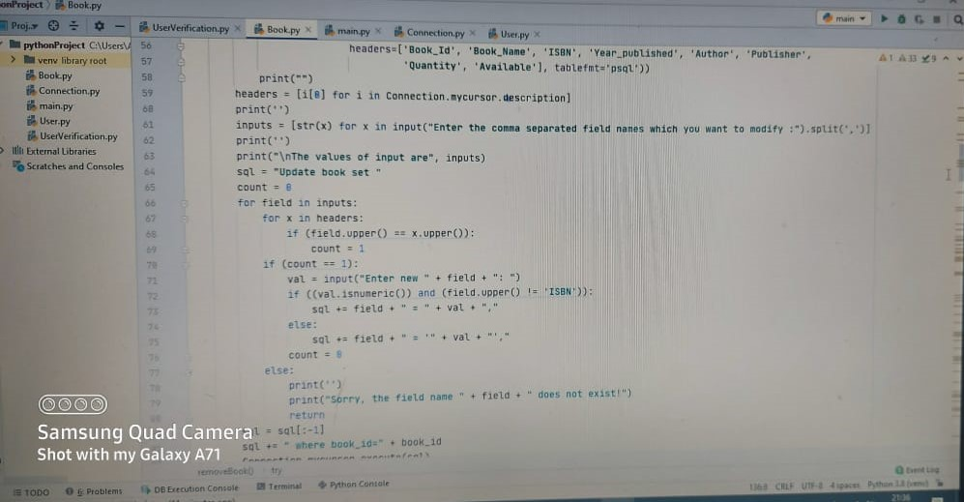

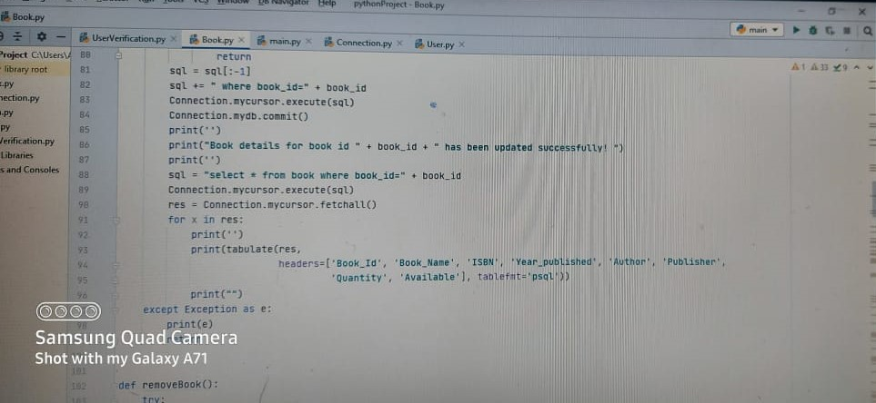

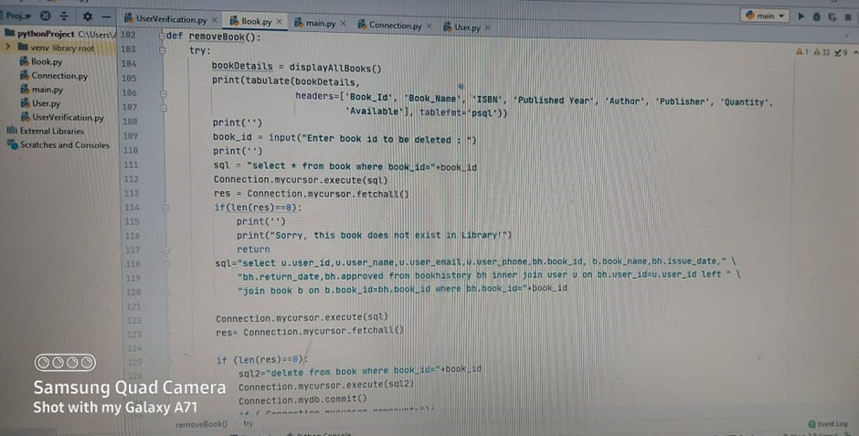

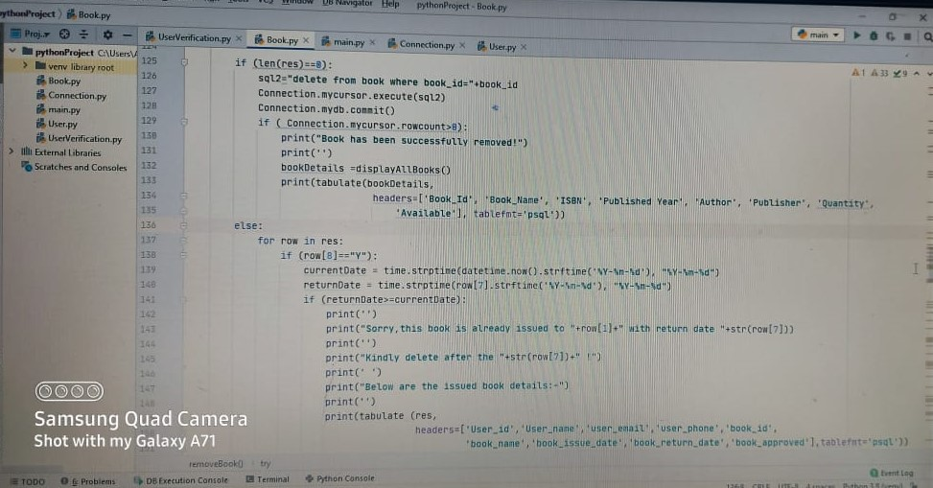

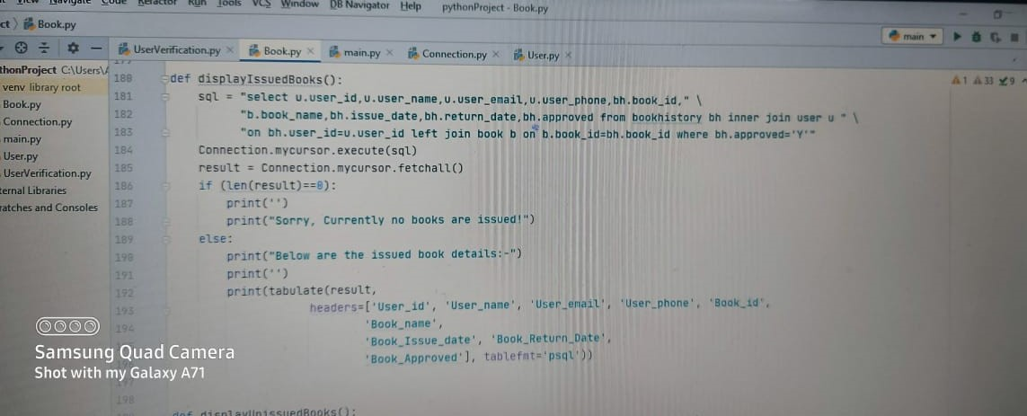

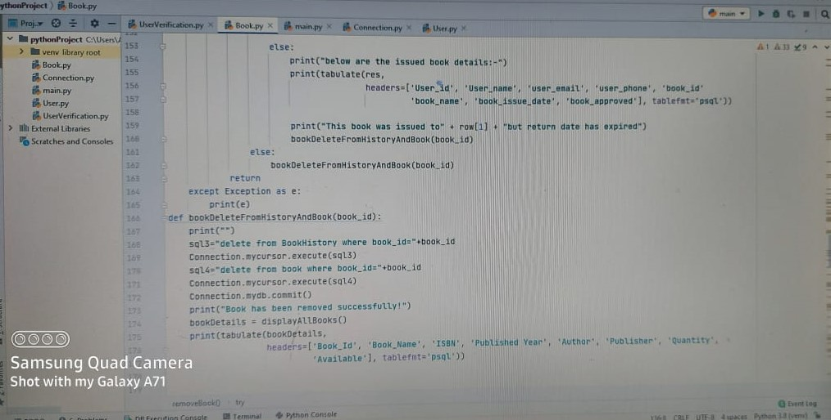

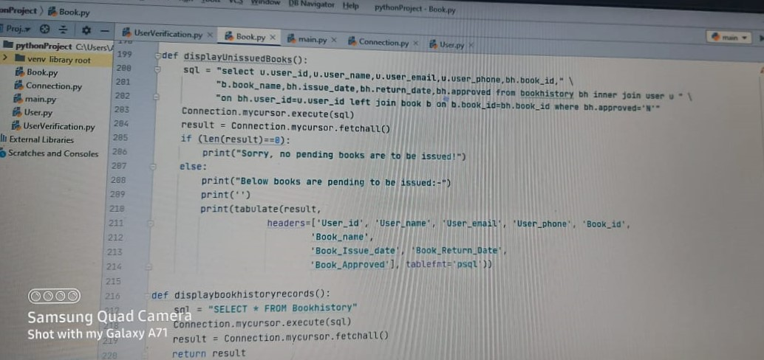

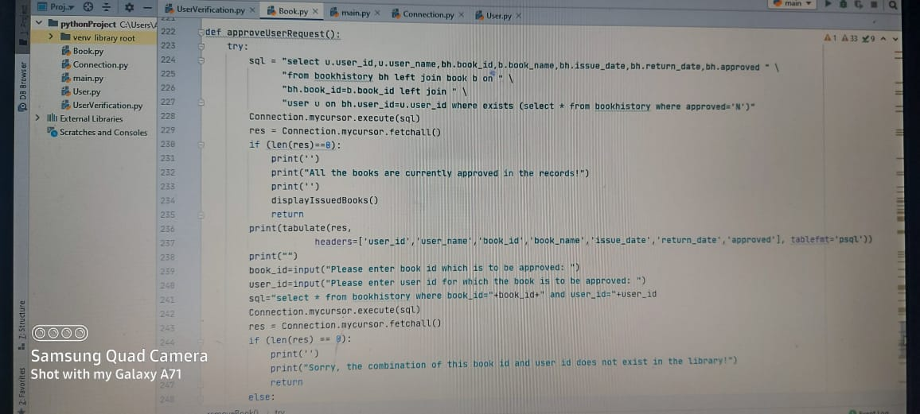

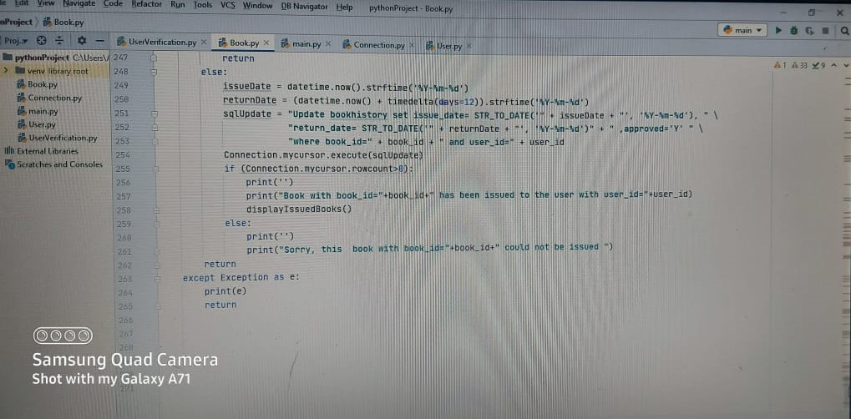

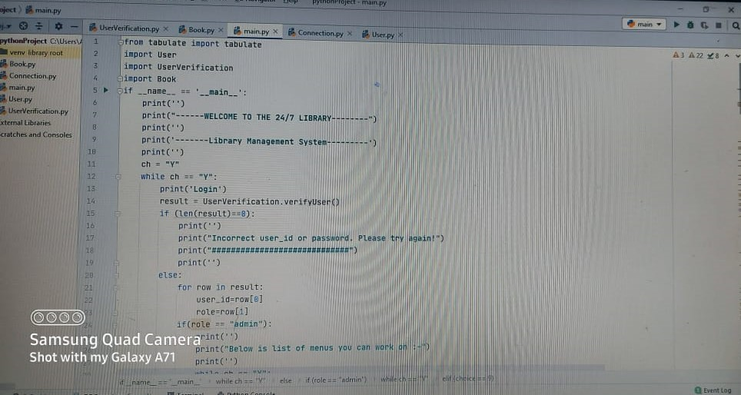

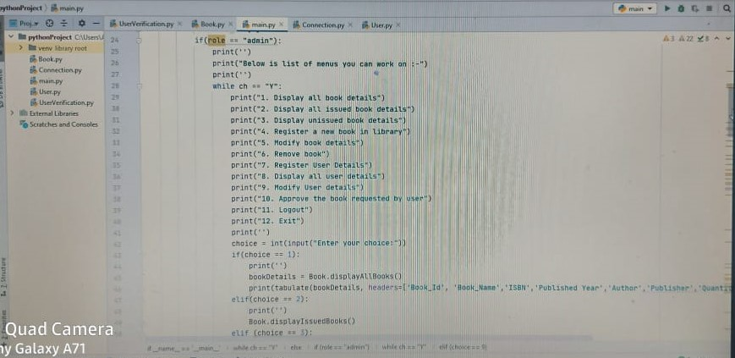

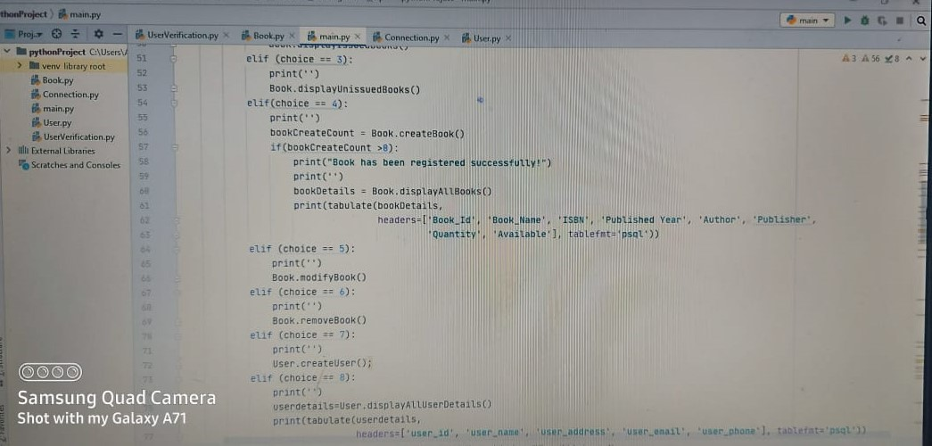

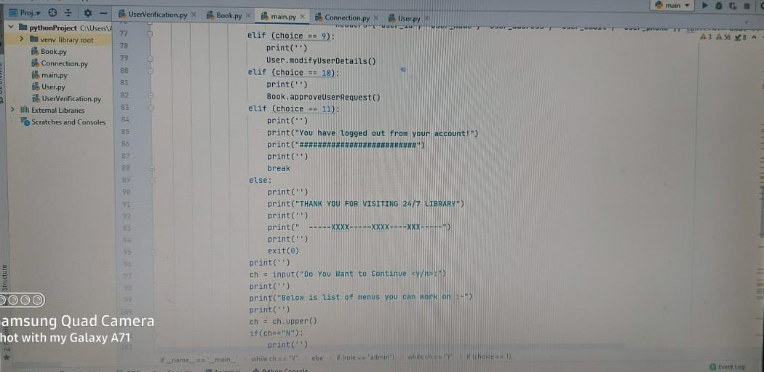

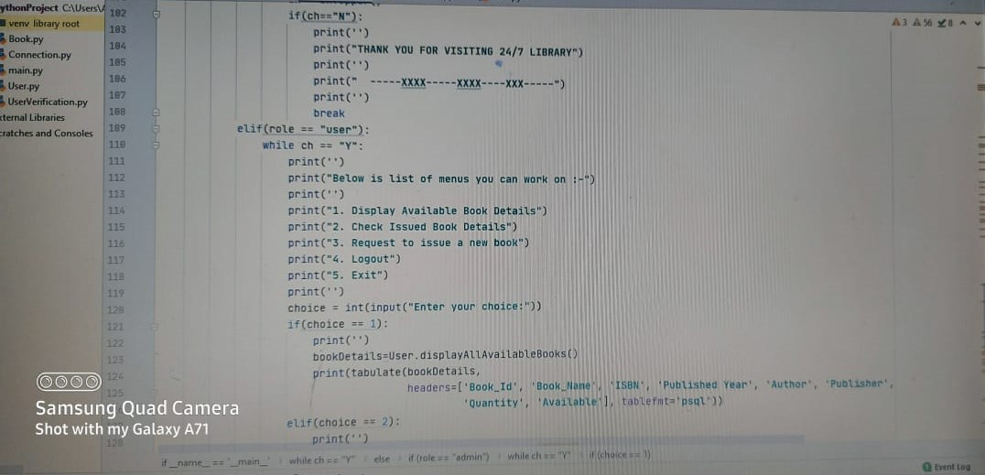

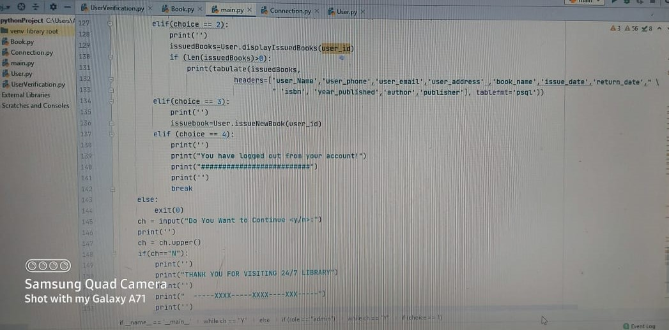

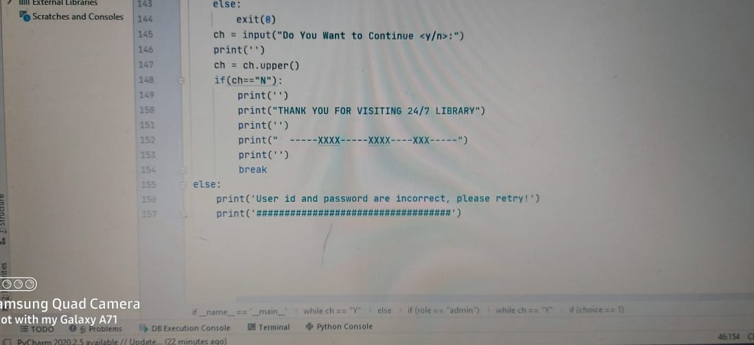

OUTPUT

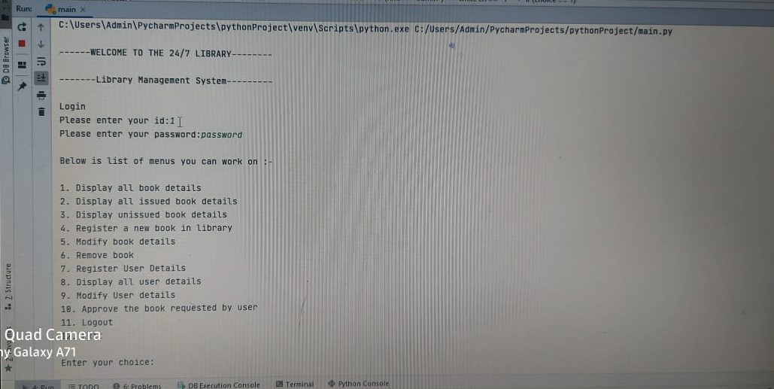

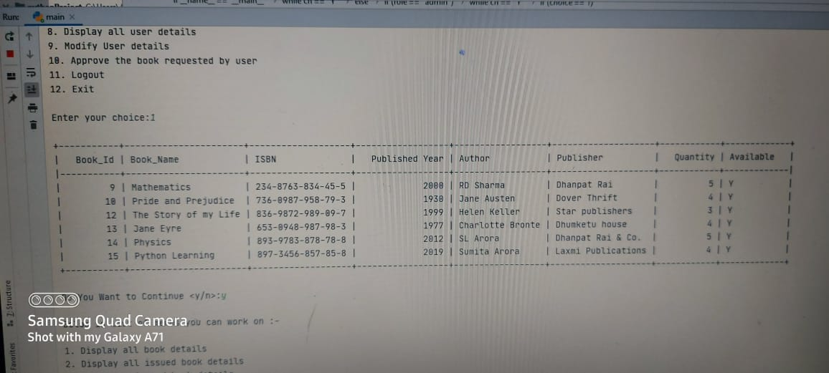

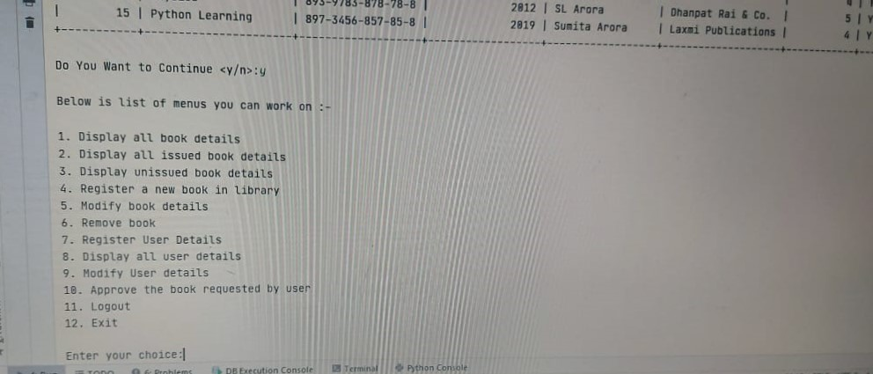

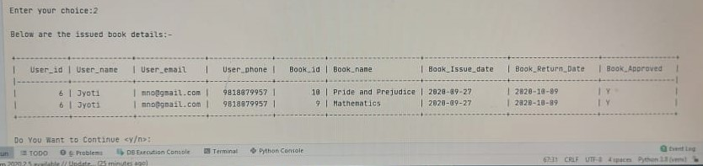

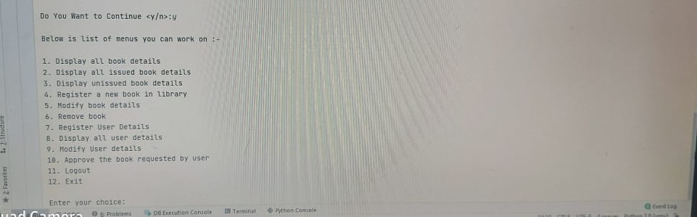

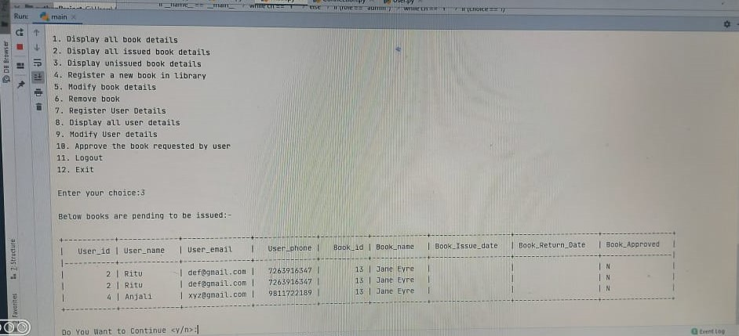

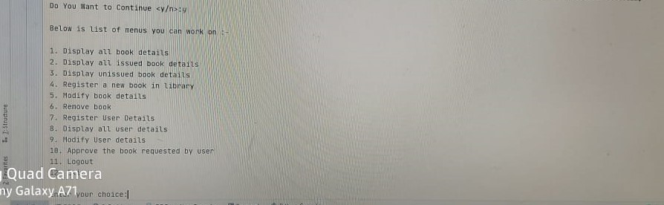

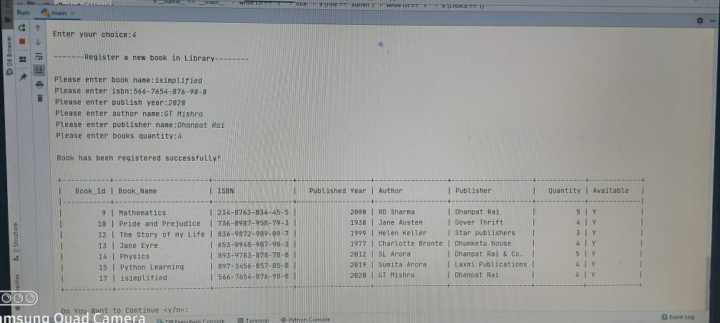

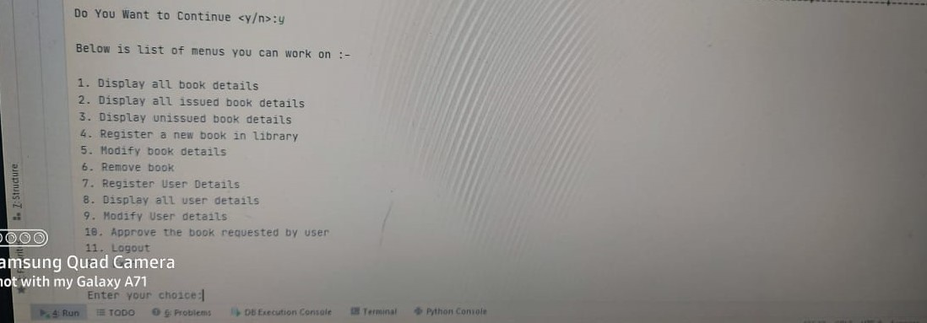

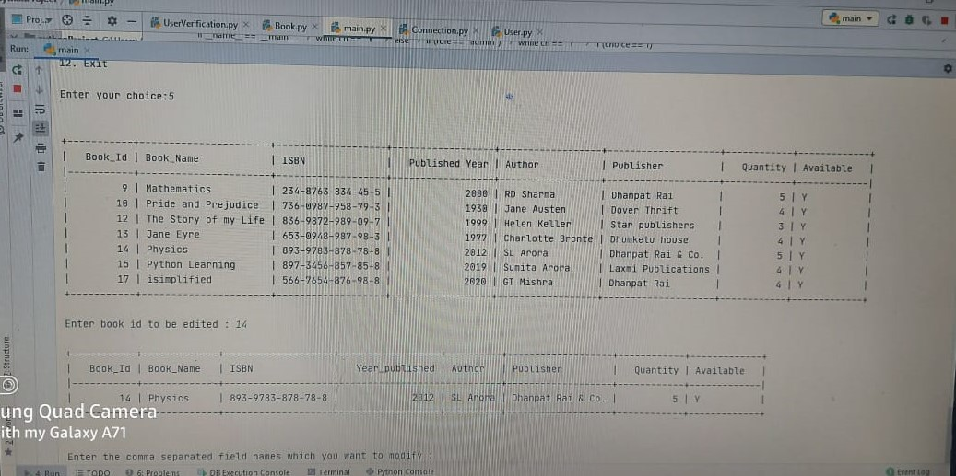

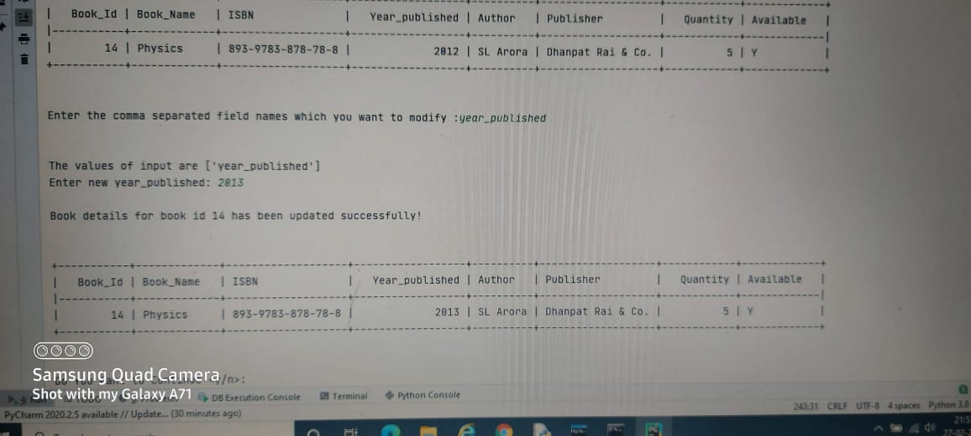

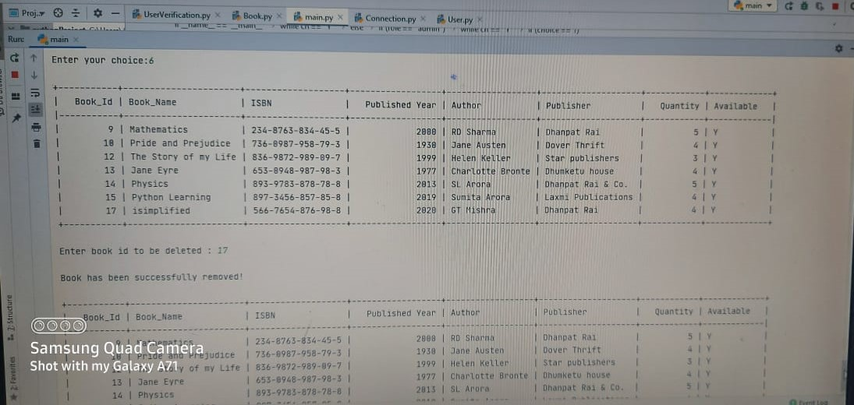

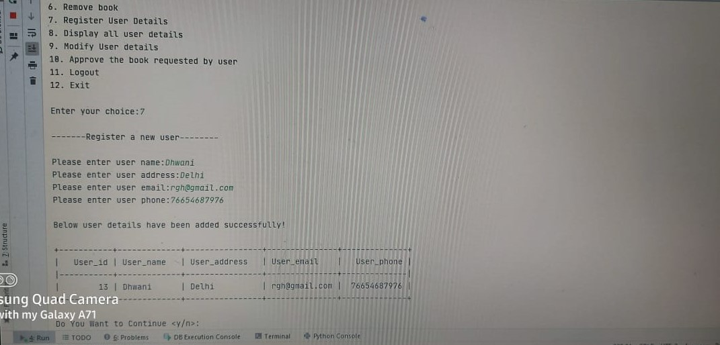

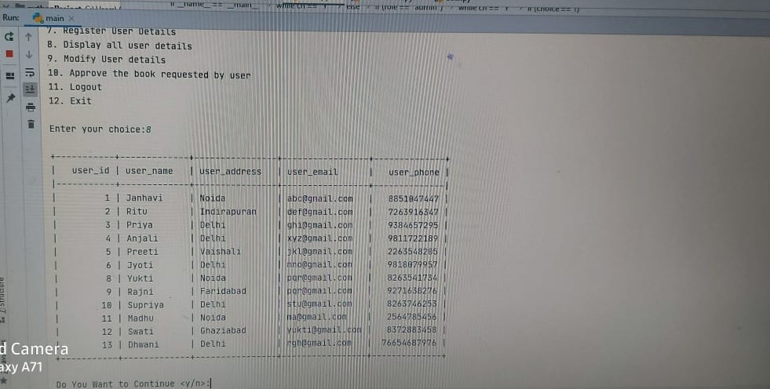

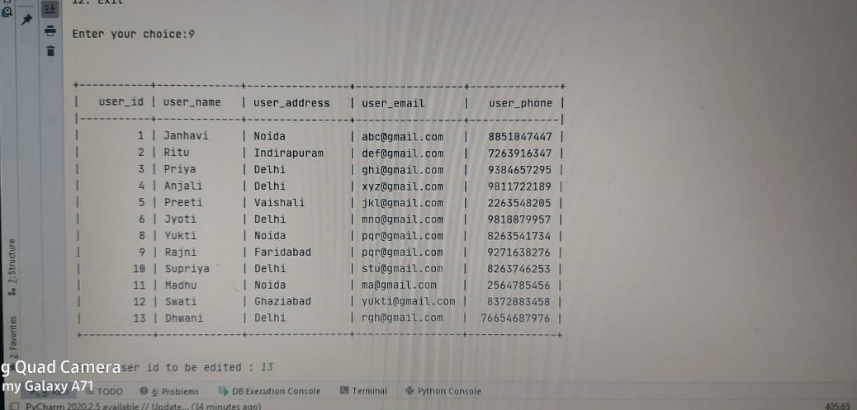

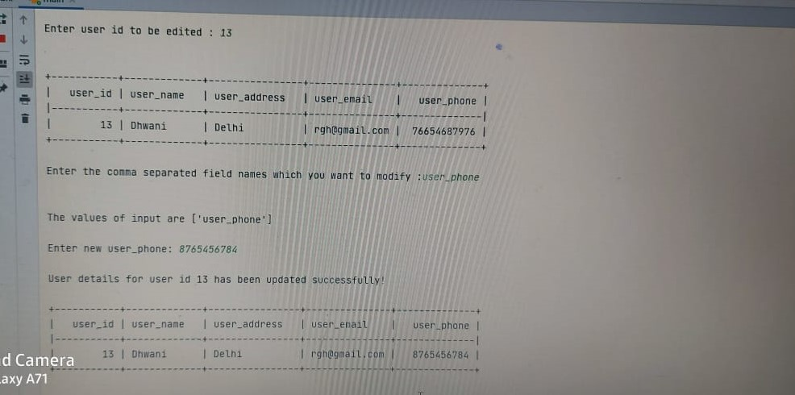

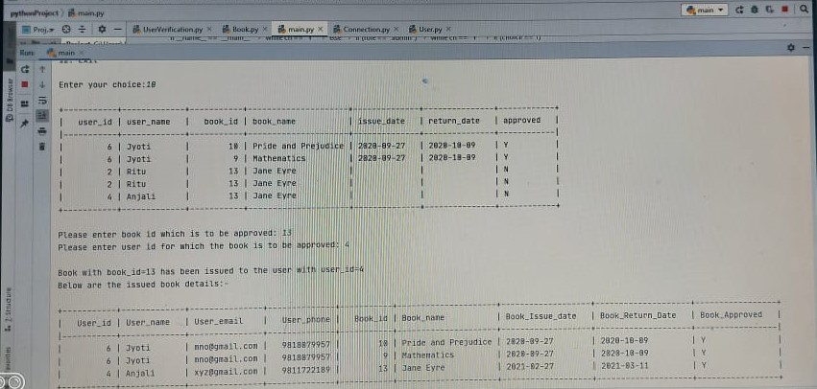

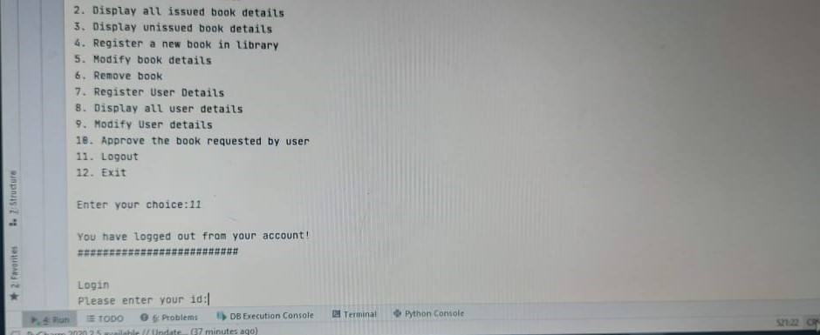

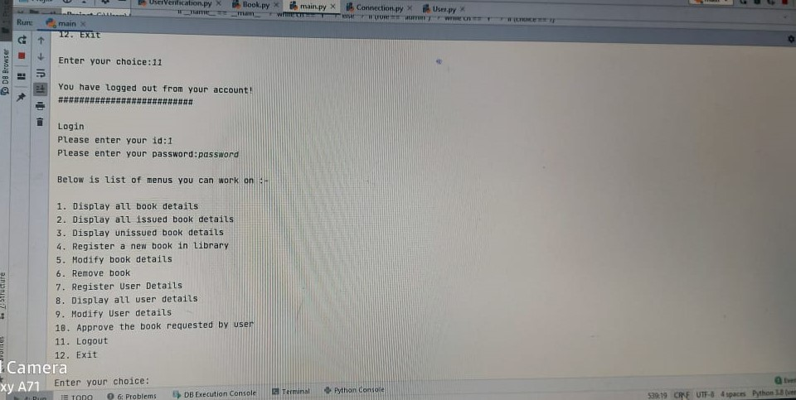

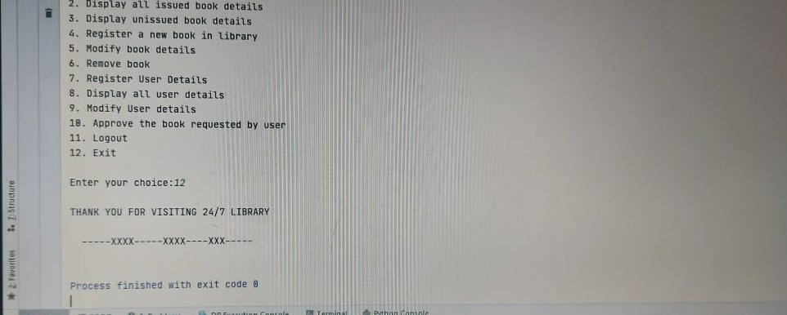

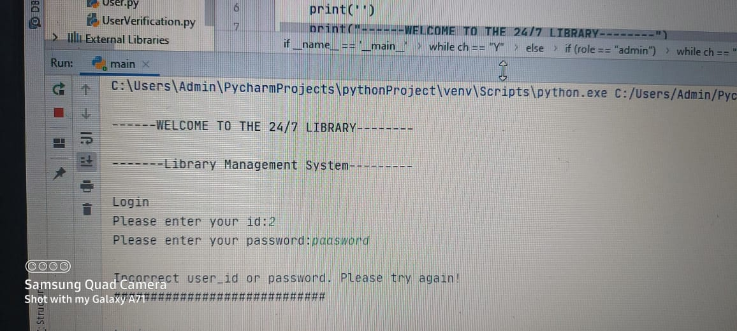

6. User Manual

7.1 How to Install Software:

Hardware Requirement-

¨ Intel Pentium/Celeron or similar processor based PC at Client/Server end.

¨ 128 MB RAM and 4GB HDD space (for Database) is desirable.

¨ Standard I/O devices like Keyboard and Mouse etc.

¨ Printer is needed for hard-copy reports.

¨ Local Area Network(LAN) is required for Client-Server Installation

Software Requirement-

¨ Windows 2000/XP OS is desirable.

¨ NetBeans Ver 5.1 or higher should be installed with JDK and JVM.

¨ MySQL Ver 6.1 with Library Database must be present at machine.

Database Installation-

The software project is distributed with a backup copy of a Database named LIBRARY with required tables. Some dummy records are present in the tables for testing purposes, which can be deleted before inserting real data. The project is shipped with manav.SQL file which installs a database and tables in the computer system.

Note: The PC must have MySQL server with user (root) and password (h) . If root password is any other password, it can be changed by running MySQL Server Instance Configure Wizard.

Start 4Program 4 MySQL 4MySQL Server 4MySQL Server Instance Config Wizard

Provide current password of root and new password as “h” , this will change the root password.

To install a MySQL database from a dump file (faisal.sql) , simply follow the following steps.

Step 1: Copy the manav.sql file in C:\Program files\Mysql\M

Step 2: Open MySQL and type the following command to create the database named travelagency.

mysql> create database library;

Step 3: Open Command Window (Start 4Run 4 cmd)

Step 4: Go to the following folder using CD command of DOS.

C:\Program files\Mysql\MySql server 5.1\Bin>

Step 5: type the following command on above prompt -

C:….\bin> mysql -u root -pmanav library <manav.sql

This will create a library database with required tables.

7.References

In order to work on this project titled – LIBRARY MANAGEMENT SYSTEM, the following books and literature are referred by me during the various phases of development of the project:

(1) The Complete Reference Python 3.7

-by Shildit

(2) MySQL, Black Book

-by Steven Holzner

(2) Understanding SQL– Gruber

(3) <http://www.mysql.org/>

(4) http://www.python.org/

(5) On-line Help of Python ®

(6) Informatics Practices for class XII

-by Sumita Arora

(7) Together with Informatics Practices

(6) Various Websites of Discussion Forum and software development activities.

Other than the above-mentioned books, the suggestions and supervision of my teacher and my classmates also helped me to develop this software project.